Step1: Open Windows PowerShell ISE and use the **Connect-AzAccount** cmdlet

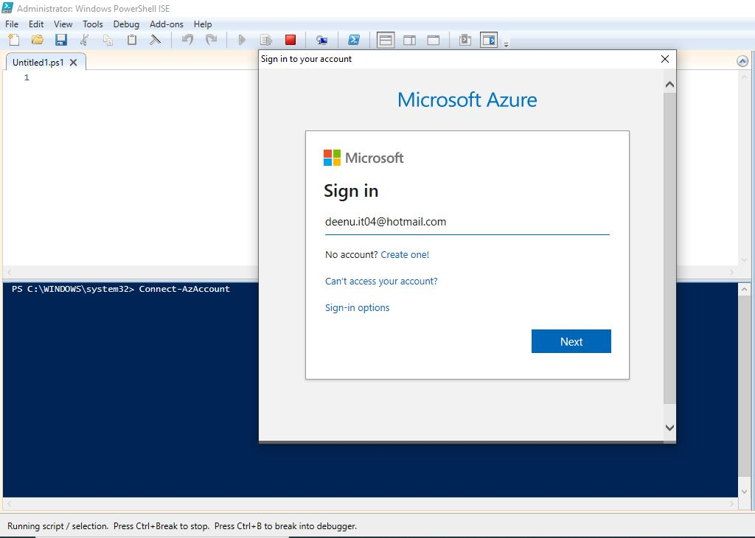

Step2: Enter credentials and sign in

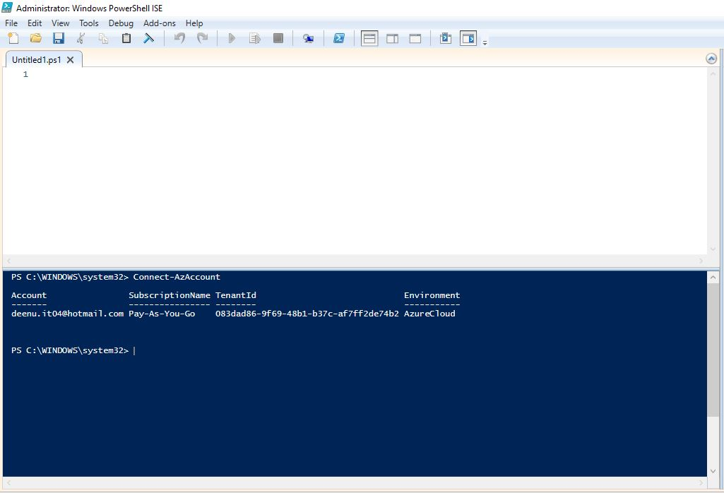

Step3 : Create Virtual Network with name **fc3TierVnet** and address space **192.168.0.0/16** in resource group **fc3TierVnetResourceGroup** andlocation **Central India**.

1. Change folder to Power Shell script folder **Vnet**.

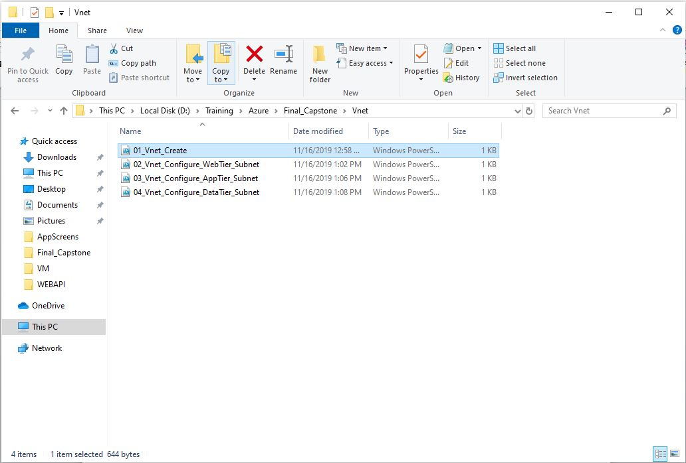

1. Execute **01_Vnet_Create.ps1** in Power Shell command line.

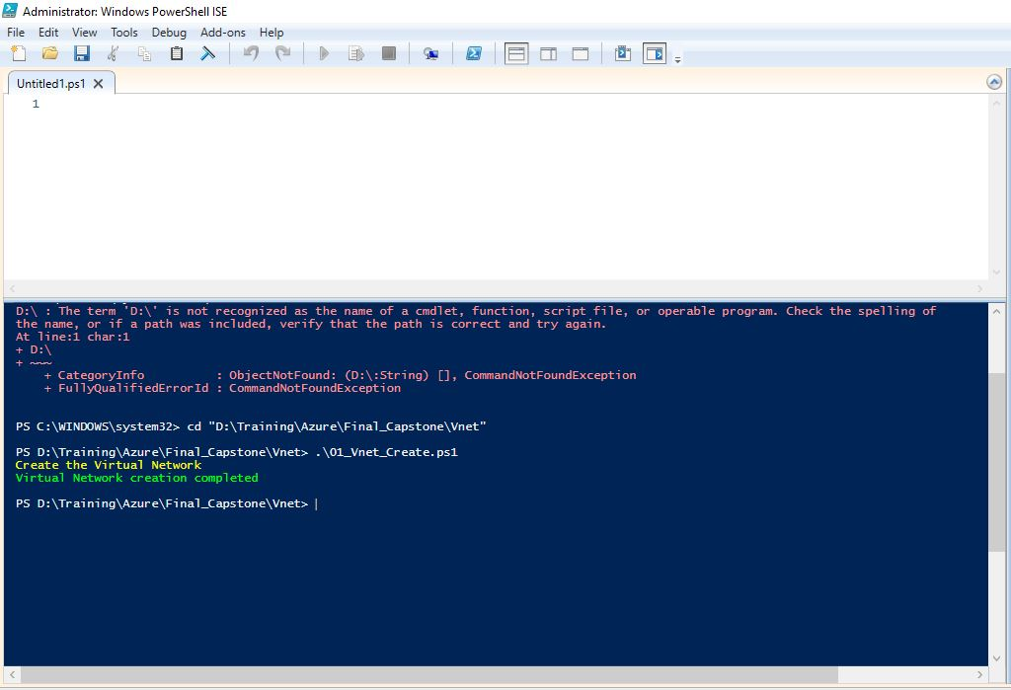

1. Verify the Virtual Network in in Azure portal

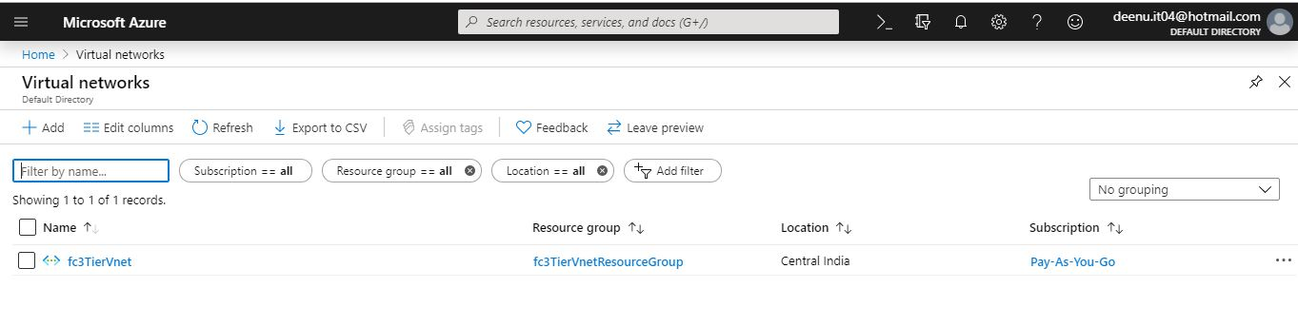

Step4: Create Subnet with name **WebTier** under **fc3TierVnet** and address space **192.168.1.0/24** in resource group **fc3TierVnetResourceGroup**.

1. Execute **02_Vnet_Configure_WebTier_Subnet.ps1** in Power Shell command line.

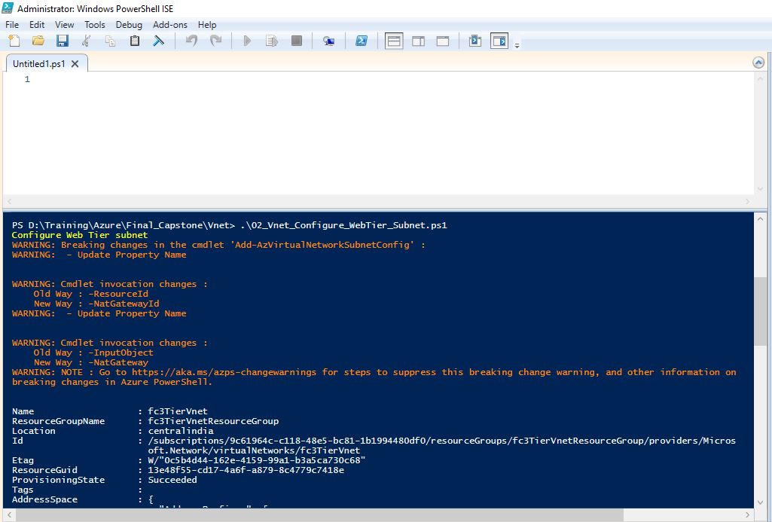

1. Verify the subnet in in Azure portal

